**Task 6:Subqueries and Nested Queries**

* **Subquery:** A subquery is a query written inside another SQL query. It is enclosed within parentheses () and is used to provide data to the main query (also called the outer query).
* **Performing operations on Employee table:**

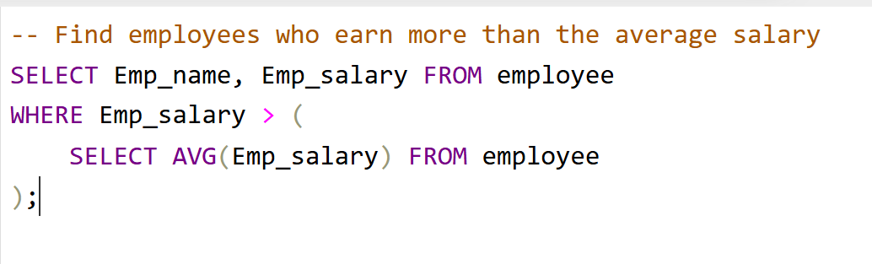

**Output:**

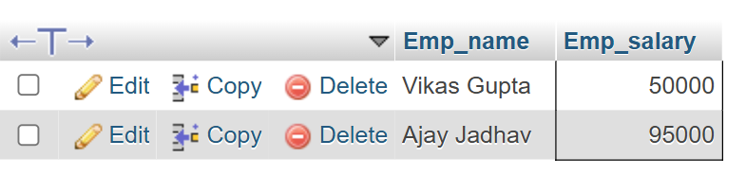

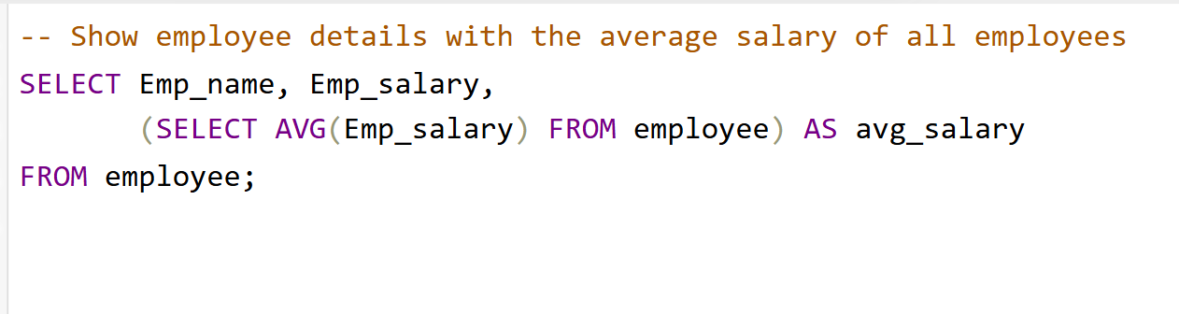

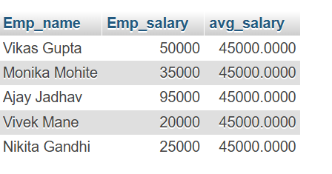**Output:**

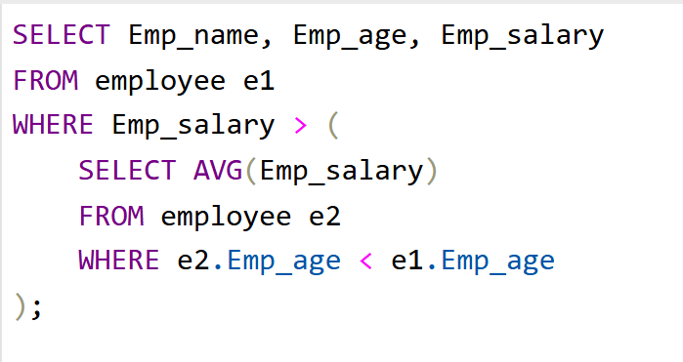

**Output:**

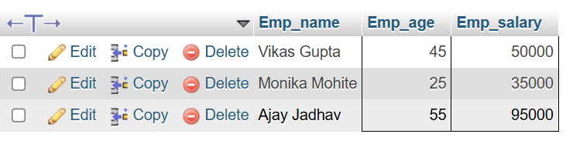

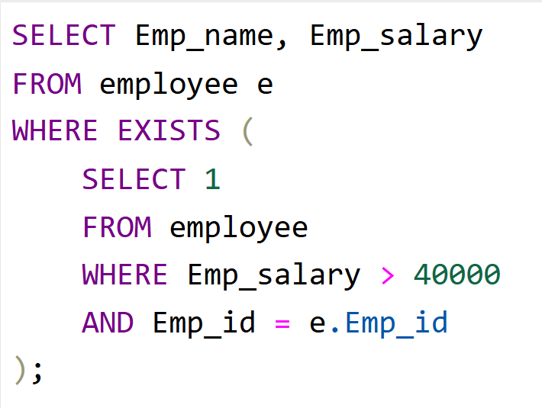

**Output:**

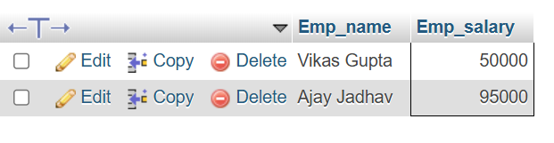

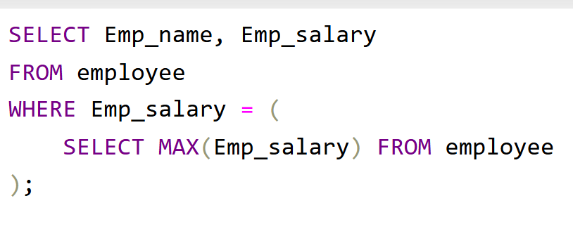

**Output:**



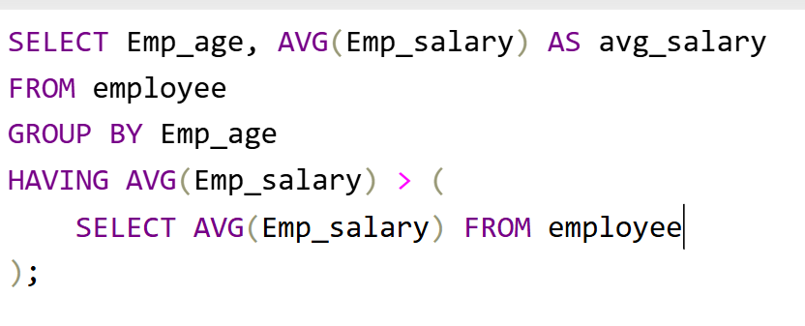

**Output:**

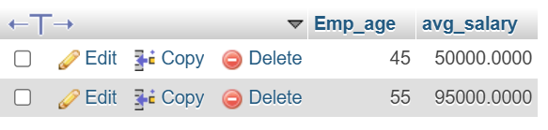

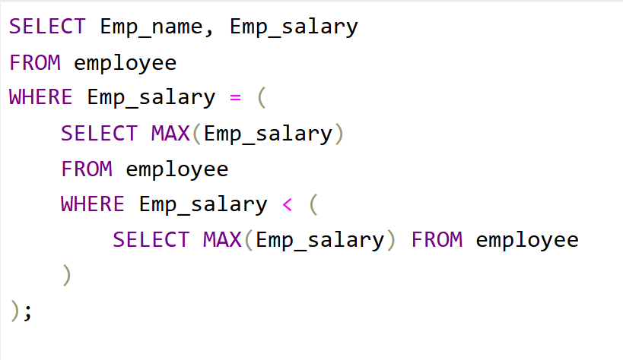

**Output:**

